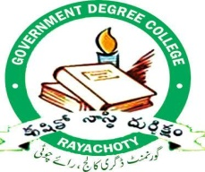
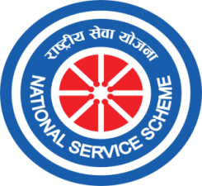
Date:
GOVERNMENT DEGREE COLLEGE, RAYACHOTY
ANNAMAYYA DIST.PIN-516269, ANDHRA PRADESH

UNIT – I
Coordinator
B.Kiran Kumar
UNIT – II
Coordinator
Dr.S.Farooq Basha

NATIONAL SERVICE SCHEME
UNIT I & II

Date: 01-Dec-2022

A Brief Report on the World AIDS Day Celebration
At Government Degree College, Rayachoty.
The NSS Unit 1 & 2 along with Red Ribbing Club Government Degree College, Rayachoty Jointly Organized World AIDS Day Awareness Program to spread the awareness on AIDS among Schools, Higher Secondary Schools and College Students and Public .On December 1st 2022 In Government Degree College, Rayachoty. The main motto of this program is to make the younger generation aware about the causes, symptoms, tests and treatments for treating HIV infection. All the student-teachers and faculty members wore red ribbons to raise awareness about AIDS. AIDS awareness slogans ‘Let’s Stop HIV Together’. ‘Open your eyes before AIDS closes them’.
On this occasion the Essay Writing and Elocution Competition Were Conducted among the Students to Aware Them about Prevention of Aids. Prizes Were Distributed Among The Students Who Got First, Second And Third Rank In The Essay Writing And Elocution Competitions. Apart from this a Rally was organized in Rayachoty City to aware the public about prevention of AIDS. All the students & Staff of the schools and Colleges have been participated in AIDS Awareness rally.
After this rally a public meeting was conducted in Government Degree College, Rayachoty. District level officer and Representatives of various organizations like Dr.Kondayya,Annamayya Distric Officer,Dr.Sailaja,District Additional Health Department, Mass Media Members and Principal,Dr.P.Harsha Latha have been Participated and focused on the causes , mode of transmission, clinical manifestations , management and prevention of HIV AIDS. At the end of the program, certificates and prizes were distributed among the students and participants in the AIDS program.

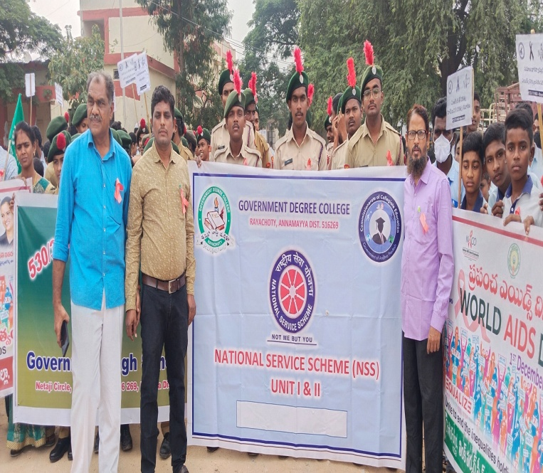  Rally on World AIDS Day | 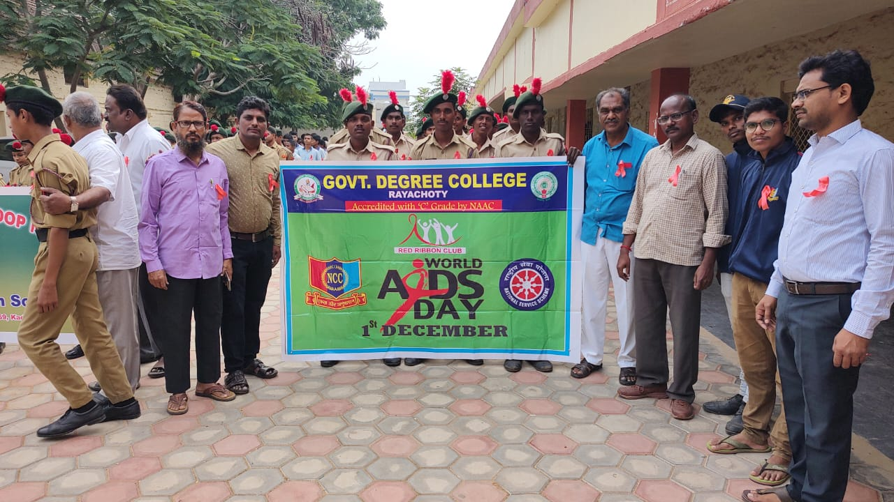  Rally on World AIDS Day
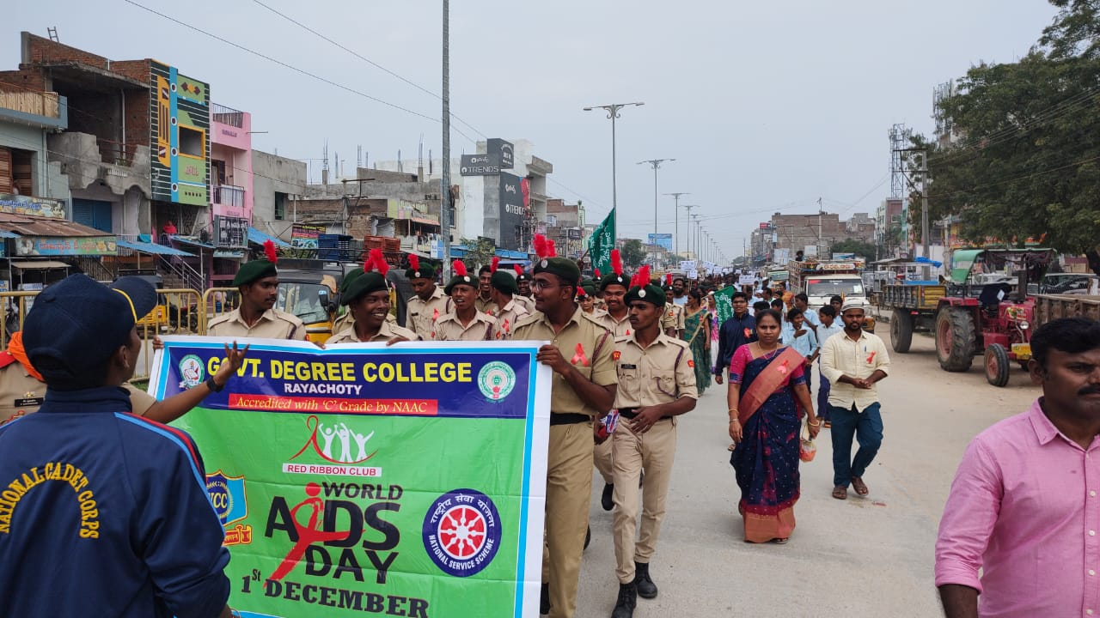  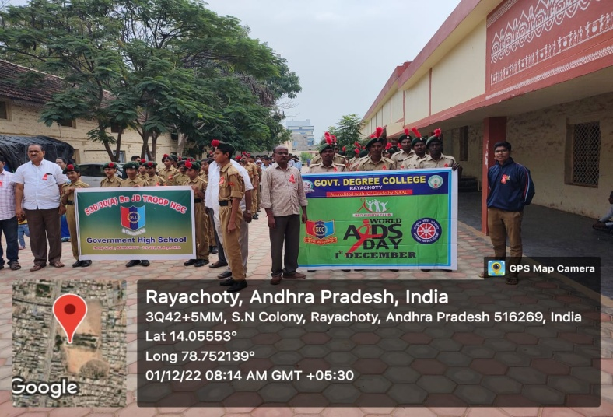  Rally on World AIDS Day | Rally on World AIDS Day
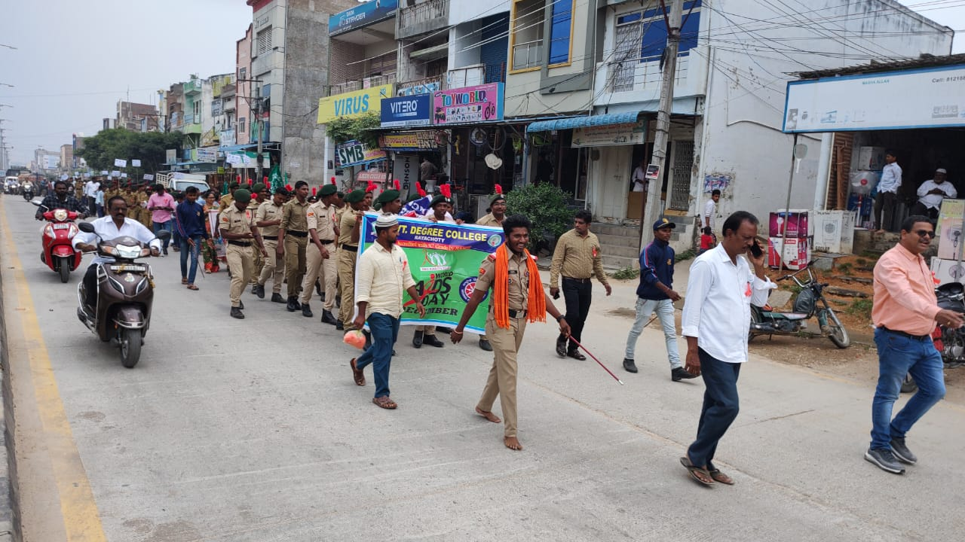  Rally on World AIDS Day | 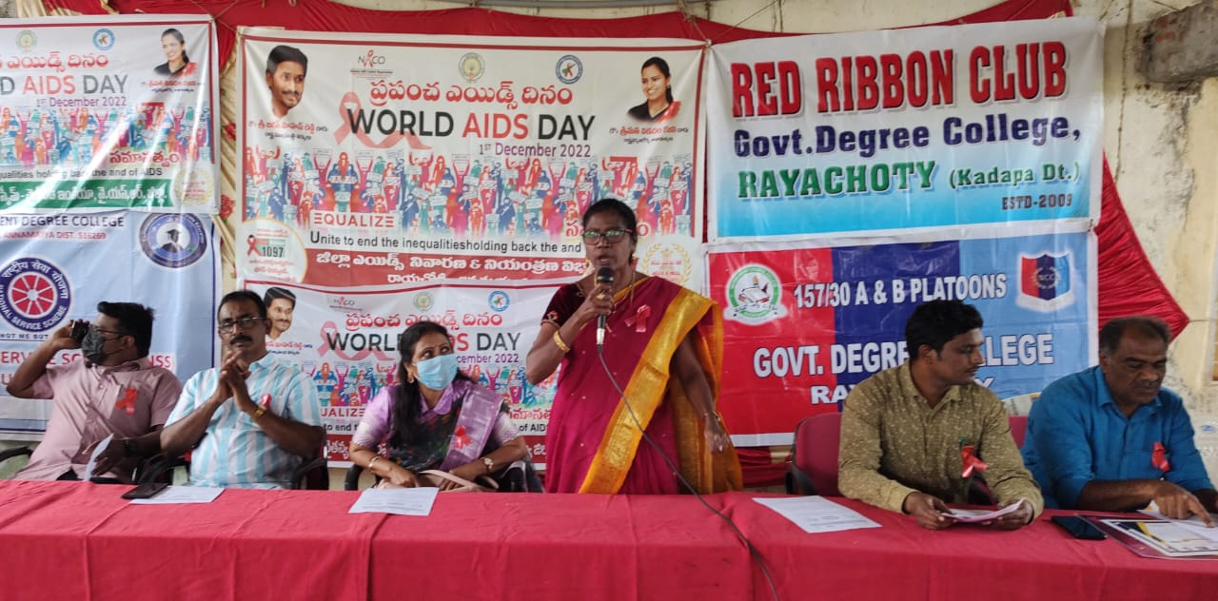  Principal, Dr.Harsha Latha Presiding over the function

Principal, Dr.Harsha Latha Addressing the function | 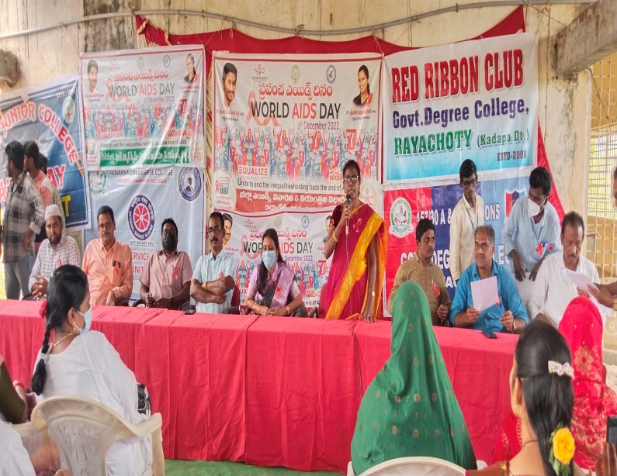  Principal, Dr.Harsha Latha Addressing the function
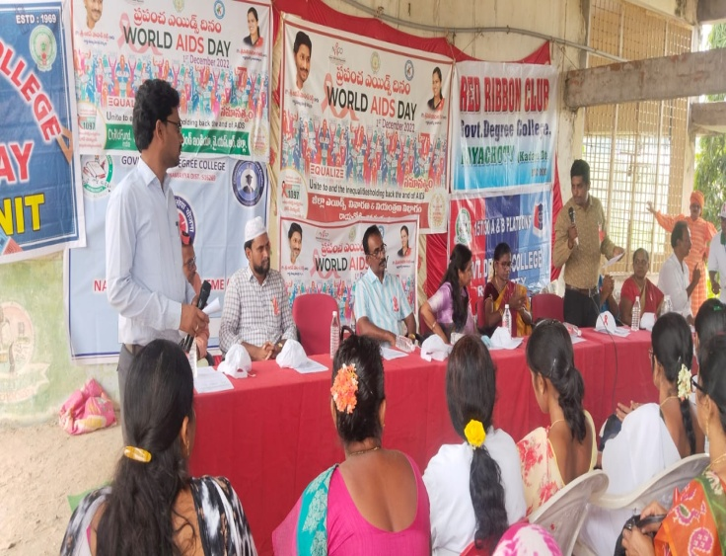  Venkata Rao RRC Coordinator addressing the Audience | 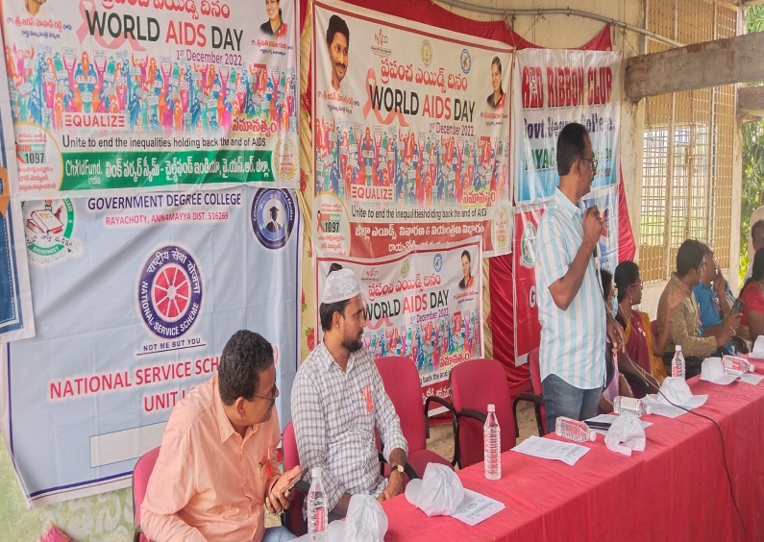  Dr.Kondaia is addressing the Audience
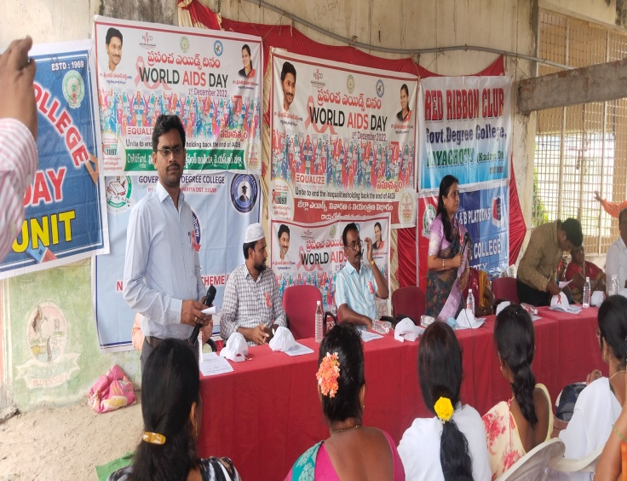B.Kiran Kumar,NSSCoordinator is addressing the Function | 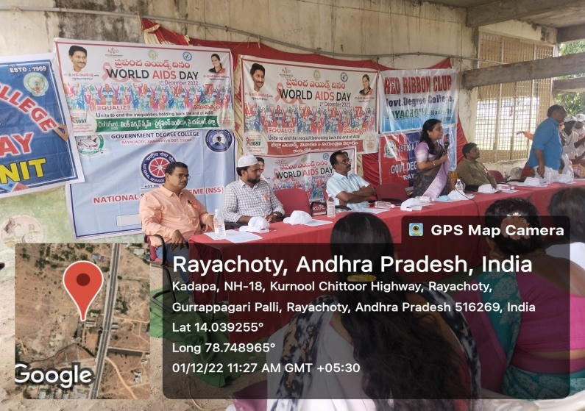  Dr.Sailaja is Addressing the Audience

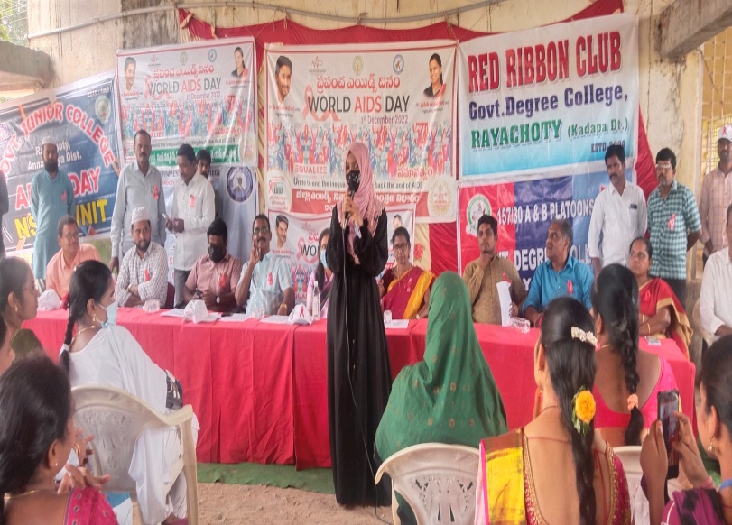  Student Aliya BA.II year Creating awareness on AIDS | 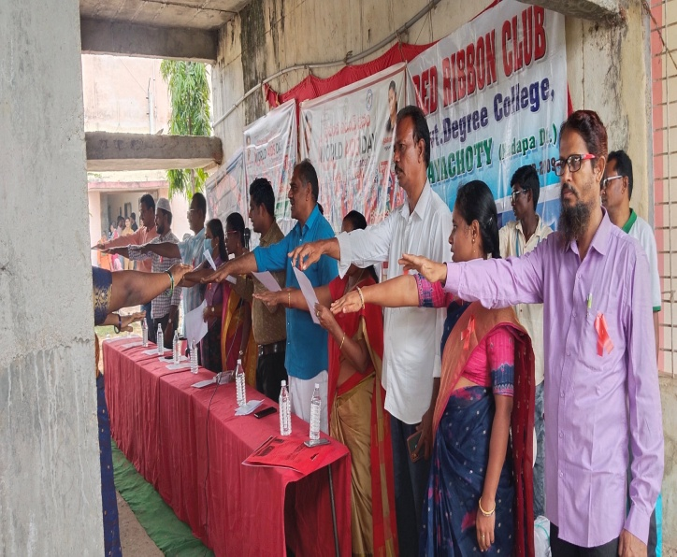  A Pledge for World Aida day
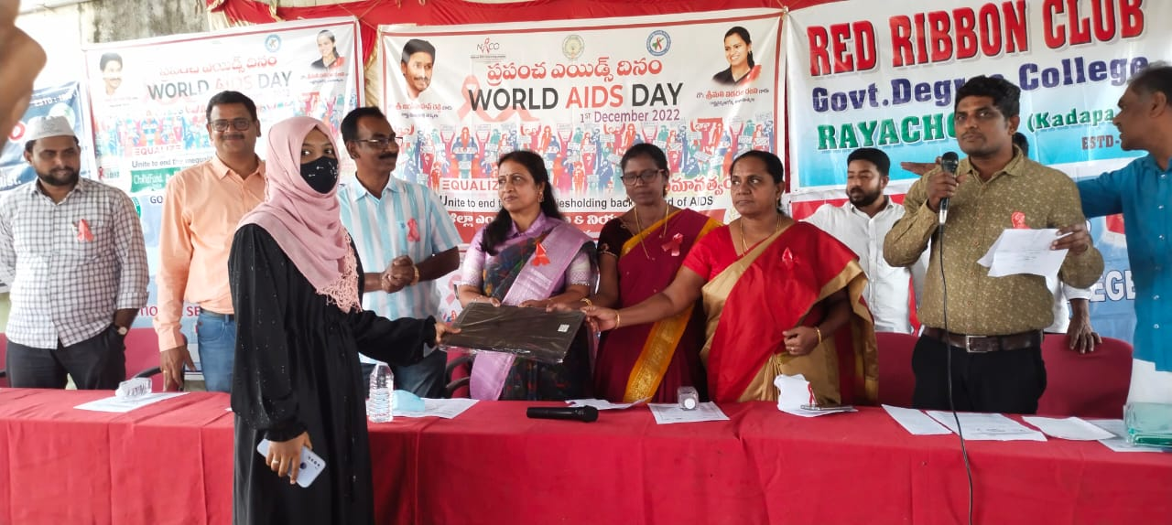  Prize Distribution | 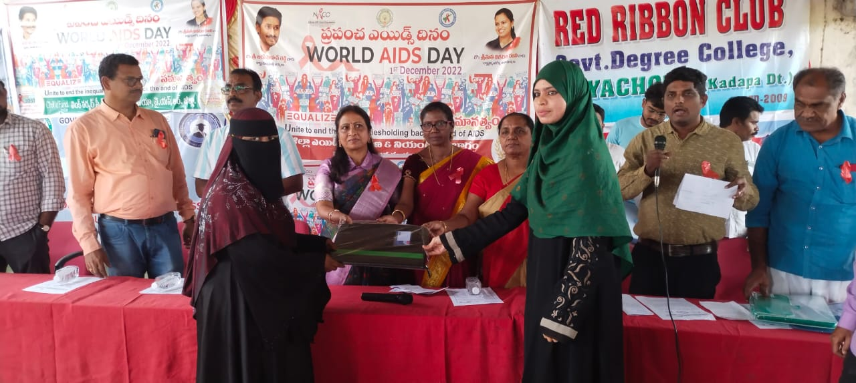  Prize Distribution
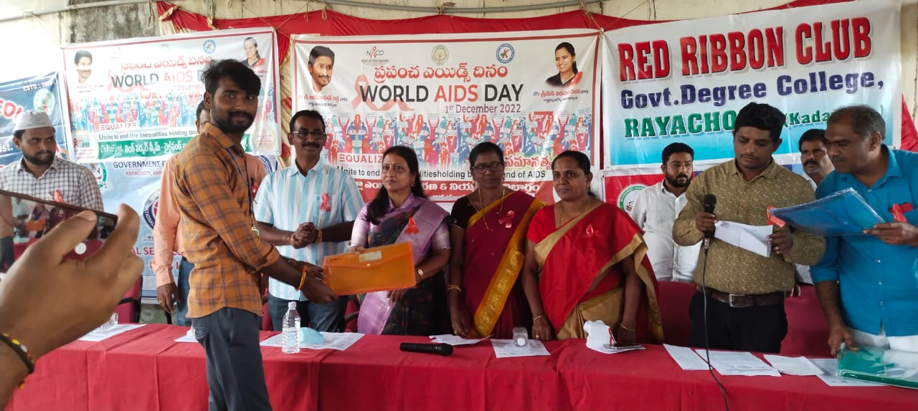  Prize Distribution | 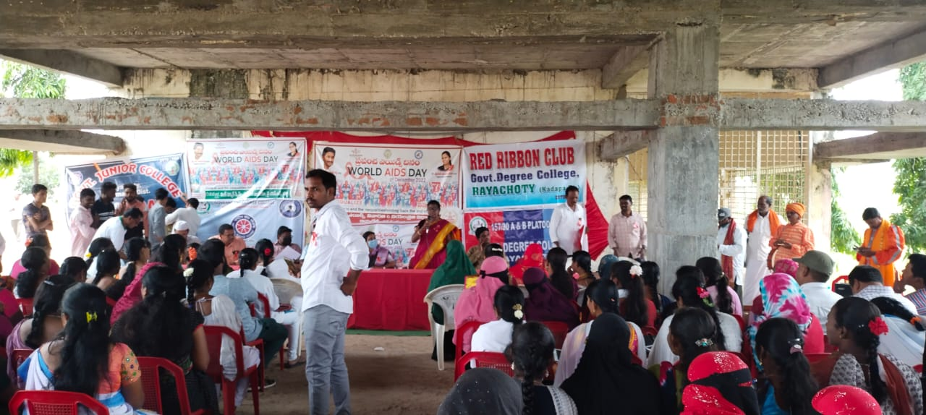  Gathering of the Students

